Lesson 1:

<https://docs.google.com/forms/d/e/1FAIpQLSeojLPGPPvScNClksIWqSu1hDcD40srjfLBdDl6uwbTg5rS8g/viewform>

<https://shecodesconnect.com/moodle/mod/lesson/view.php?id=3491&forceview=1>

<https://www.codecademy.com/catalog/subject/all>

<https://stackoverflow.com/> שאלות

IDLE editor for python

Shell – window of IDLE

slack – אפליקציה לשיתוף

<https://maria-suj2403.slack.com/customize/profile>

טופס נוכחות

<https://docs.google.com/forms/d/e/1FAIpQLSeojLPGPPvScNClksIWqSu1hDcD40srjfLBdDl6uwbTg5rS8g/viewform>

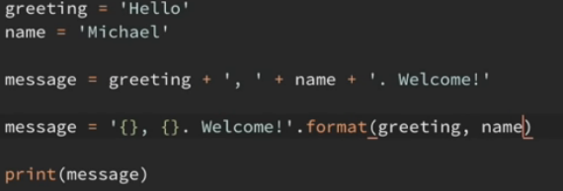

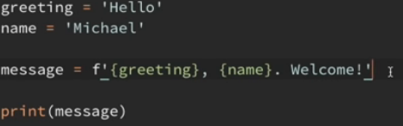

from datetime import date

today = date.today()

print("Today's date:", today)

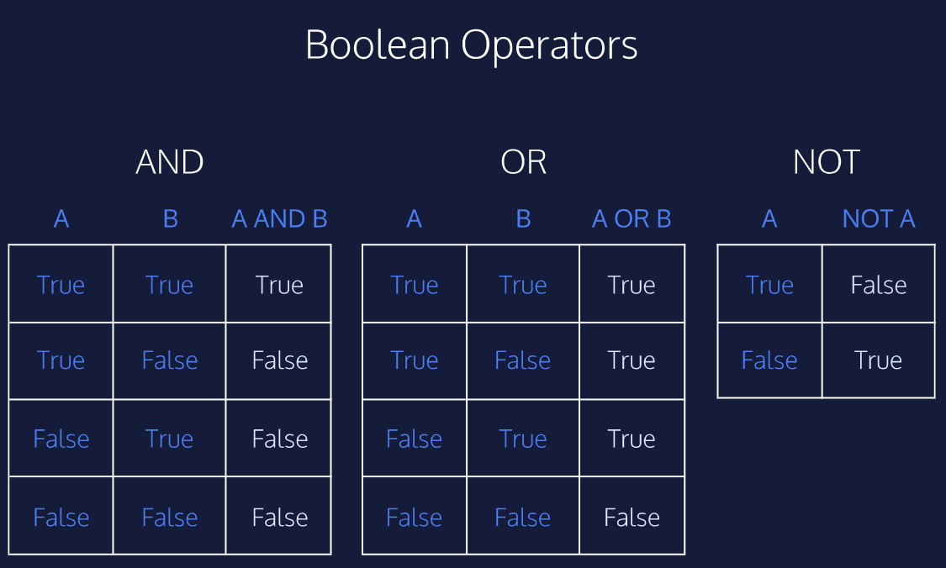

דוגמא לפונקציה

def using_control_once():

if _______:

return "Success #1"

def using_control_again():

if _______:

return "Success #2"

print using_control_once()

print using_control_again()

-----------------------------

def not_string(str):

if len(str) >= 3 and str[:3] == "not":

return str

return "not " + str

def missing_char(str, n):

front = str[:n] # up to but not including n

back = str[n+1:] # n+1 through end of string

return front + back

def front_back(str):

if len(str) <= 1:

return str

mid = str[1:len(str)-1] # can be written as str[1:-1]

# last + mid + first

return str[len(str)-1] + mid + str[0]

def myFun(x, y, z):

x = input("Name")

y = input("SecondName")

z = input("Year")

print("your initials are" + x[0] + y[0] + ' and you are ' + str(2020-1989) + 'years old' )

myFun()

built-in Functions

<https://docs.python.org/2/library/functions.html>

מה כולל המודול:

import math # Imports the math module

everything = dir(math) # Sets everything to a list of things from math

print everything

<https://github.com/GaliaLael/Simon-Game/blob/master/simon-game.js>

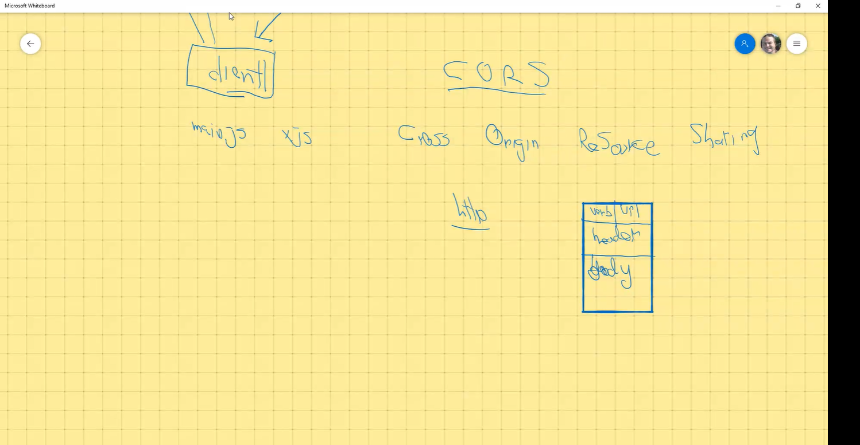

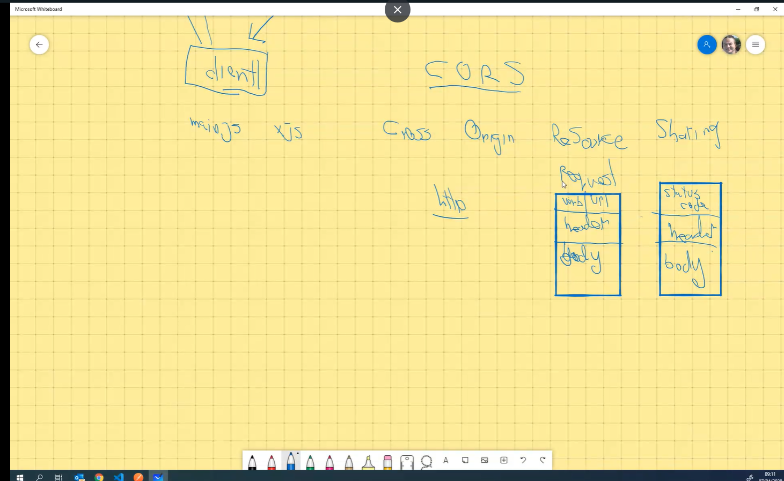

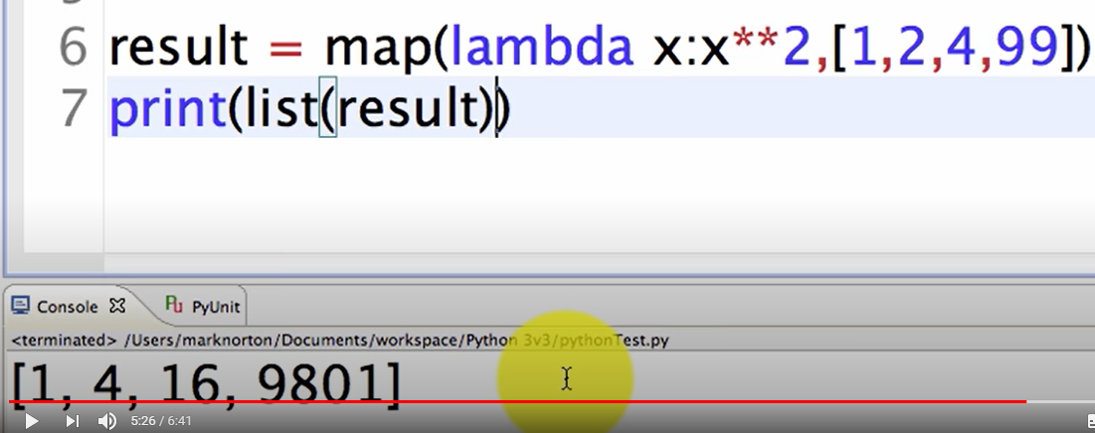

import math # Imports the math module

everything = dir(math) # Sets everything to a list of things from math

print everything # Prints 'em all!

פונקציות מובנות:

<https://docs.python.org/2/library/functions.html>

פונקציות:

1. Str:  
   isalnum, split, replace, join, count, find, index
2. List:  
   append, extend, pop, remove, insert, sort, count, index
3. Loops:

Range

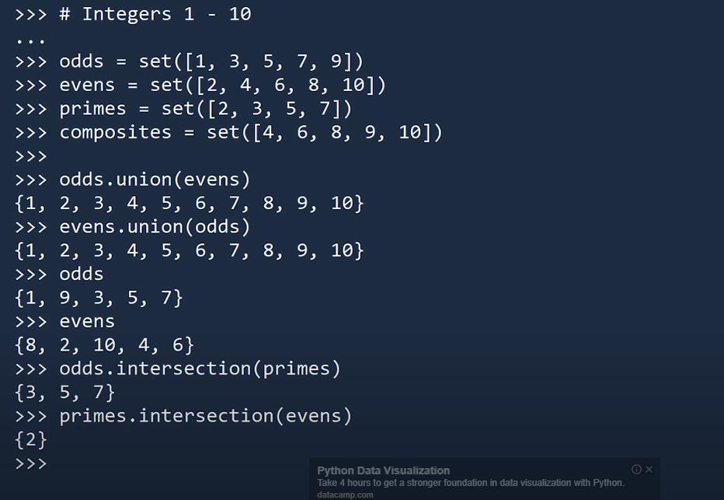

Dir(primes)

Dictionary = {'key1' : 1, 'key2' : 2, 'key3' : 3}

List = ["ant", "bat", "cat"]

Help (str)

